* **Create Table Name : Student and Exam**

**Student Table Exam table**

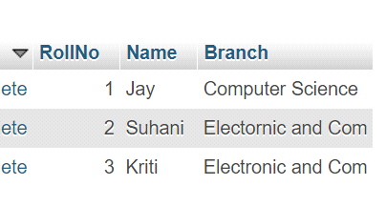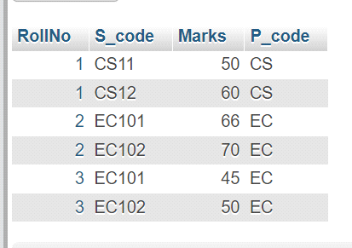

* **Create table given below: Employee and Incentive Table**

**Employee Table**

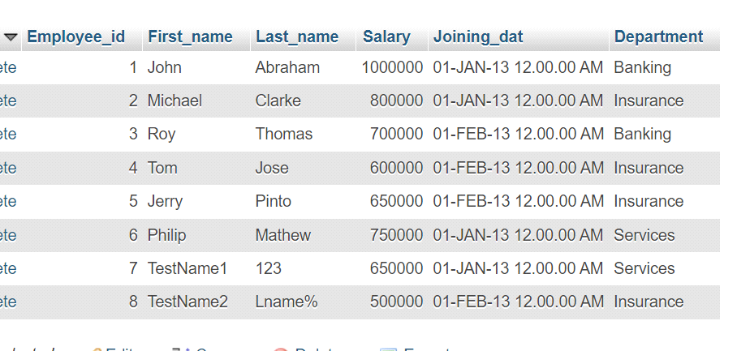

**Incentive Table**

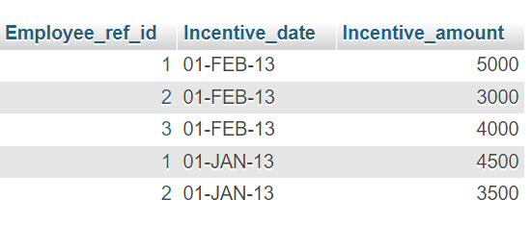

* **Get First_Name from employee table using Tom name “Employee Name”.**

**Query :-** SELECT First_name FROM employee WHERE First_name = "TOM";

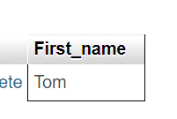

* **Get FIRST_NAME, Joining Date, and Salary from employee table.**

**Query :-** SELECT First_name,Joining_date,Salary FROM employee;

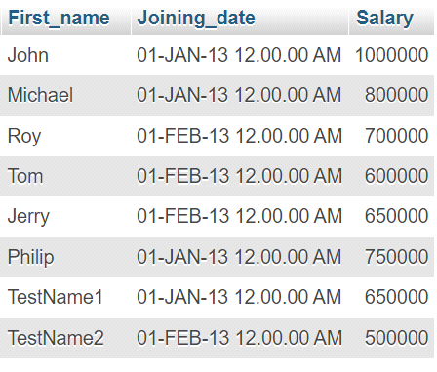

* **Get all employee details from the employee table order by First_Name Ascending and Salary descending?**

**Query :-** SELECT * FROM employee ORDER BY First_name ASC , Salary DESC;

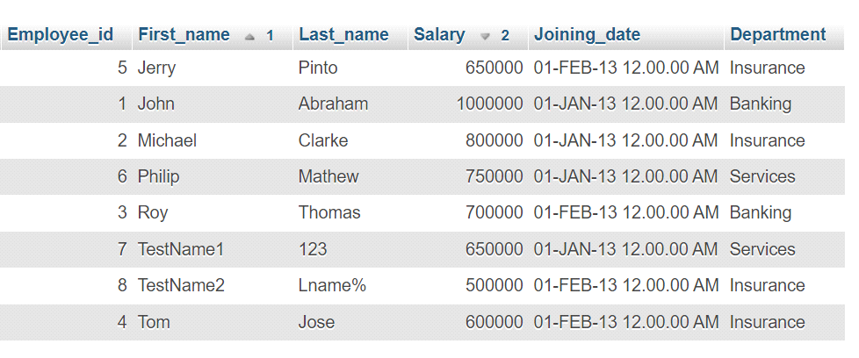

* **Get employee details from employee table whose first name contains ‘J’.**

**Query :-** SELECT * FROM employee WHERE First_name like "%J%";

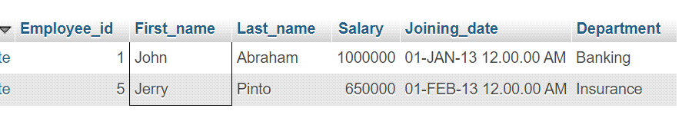

* **Get department wise maximum salary from employee table order by salaryascending?**

**Query :-** SELECT Department, max(SALARY) MAXSALARY FROM employee GROUP BY Department ORDER BY MAXSALARY ASC;

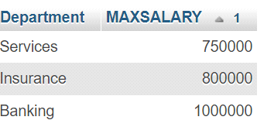

* **Select first_name, incentive amount from employee and incentives table forthose employees who have incentives and incentive amount greater than 3000**

**Query :-** SELECT employee.First_name , incentive.Incentive_amount FROM employee LEFT JOIN incentive ON employee.Employee_id = incentive.Employee_ref_id WHERE incentive.Incentive_amount > 3000;

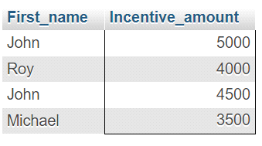

* **Create After Insert trigger on Employee table which insert records in view table**

**Query :-**

* **Create table given below: Salesperson and Customer**

**Salesperson Table Customer Table**

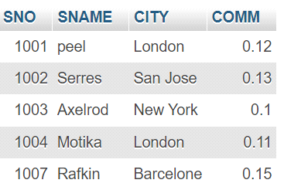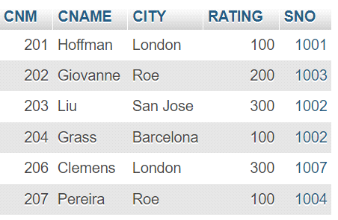￼**￼**

* **All customer rating for more than 100.**

**Query :-** SELECT CNAME, RATING FROM `customer` WHERE Rating > 100;

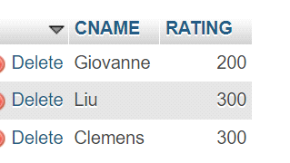

* **Names and cities of all salespeople in London with commission above 0.12**

**Query :-** SeLECT SNAME ,CITY FROM salesperson WHERE CITY = "london" AND COMM >0.12;

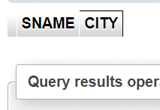

* **All salespeople either in Barcelona or in London**

**Query :-** SELECT * FROM `salesperson` WHERE CITY = "Barcelona" Or CITY = "London";

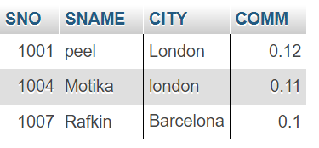

* **All salespeople with commission between 0.10 and 0.12.**

**Query :-** SELECT * FROM `salesperson` WHERE COMM BETWEEN 0.10 AND 0.12;

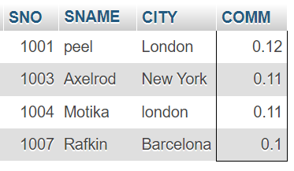

* **All customers excluding those with rating <= 100 unless they are located in Rome**

**Query :-** SELECT * FROM customer WHERE Rating <= 100;

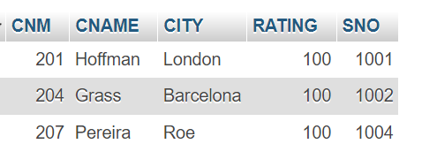

* **Write a SQL statement that displays all the information about all salespeople**

**Query :-** Select * from salesperson

* **From the following table, write a SQL query to find orders that are delivered by a salesperson with ID. 5001. Return ord_no, ord_date, purch_amt.**

**Query :-**

* **From the following table, write a SQL query to select a range of products whose price is in the range Rs.200 to Rs.600. Begin and end values are included. Return pro_id, pro_name, pro_price, and pro_com.**

**Query :-** SELECT PRO_ID , PRO_Name,PRO_PRICE , PRO_COM FROM product WHERE PRO_PRICE BETWEEN 200 AND 600;

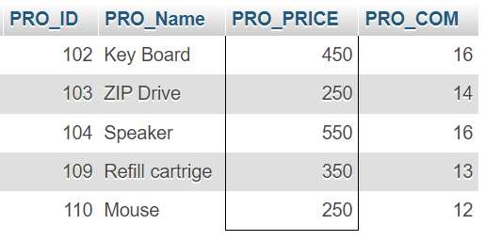

* **From the following table, write a SQL query to calculate the average price for a manufacturer code of 16. Return avg.**

**Query :-** SELECT AVG(pro_price) FROM product WHERE pro_com = 16;

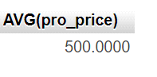

* **From the following table, write a SQL query to display the pro_name as 'Item Name' and pro_priceas 'Price in Rs.'**

**Query :-** SELECT PRO_NAME as "Item Name", PRO_PRICE AS "Price in Rs." FROM product;

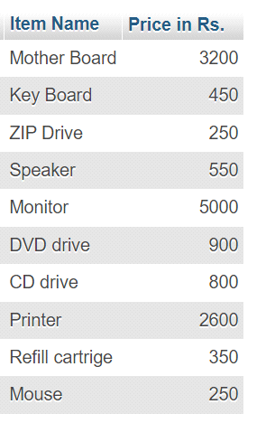

* **From the following table, write a SQL query to find the items whose prices are higher than or equal to $250. Order the result by product price in descending, then product name in ascending. Return pro_name and pro_price.**

**Query : -** SELECT PRO_NAME,PRO_PRICE FROM product WHERE PRO_PRICE >= 250 ORDER by PRO_PRICE DESC ,PRO_NAME ASC;

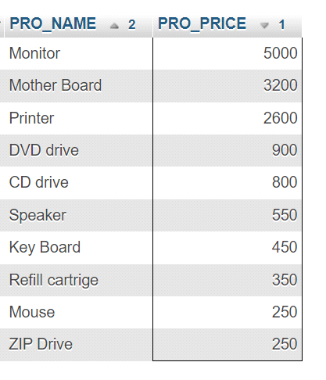

* **From the following table, write a SQL query to calculate average price of the items for each company. Return average price and companycode**

**Query :-** SELECT AVG(PRO_PRICE) FROM product;

